HYSTER SALES LITERATURE & PROMOTIONAL

GIFTS ON-LINE USER GUIDE

Contents

- Accessing the on-line ordering system
- Checking and ordering stock
- Pricing up your order
- Track and trace
- Address book
- Useful information

Nb, New service available as of Monday 18th August 2003

Accessing the online ordering system

- Type http://www.sprintexpress.co.uk/hyster/ into your web browser

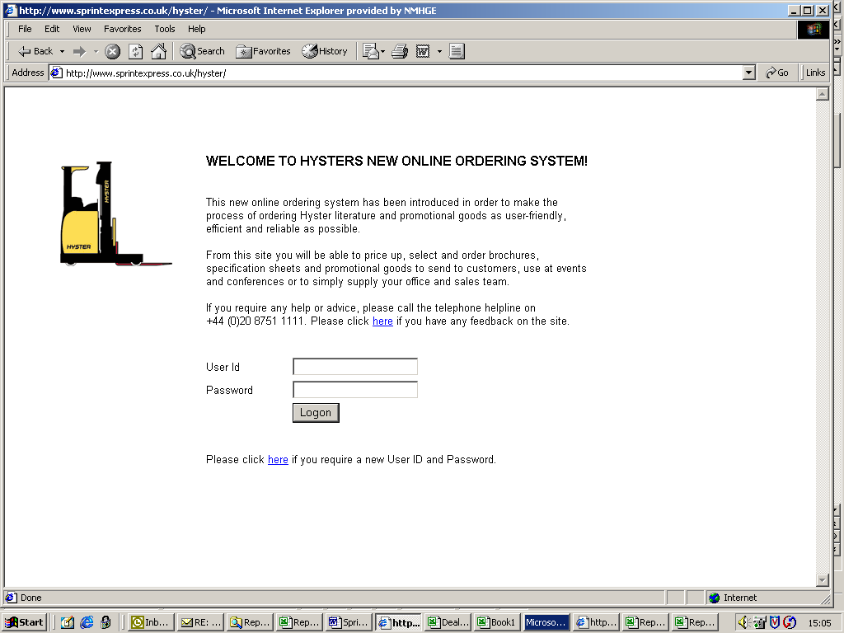

- Enter your User ID and Password into the appropriate field and click on ‘Logon’.

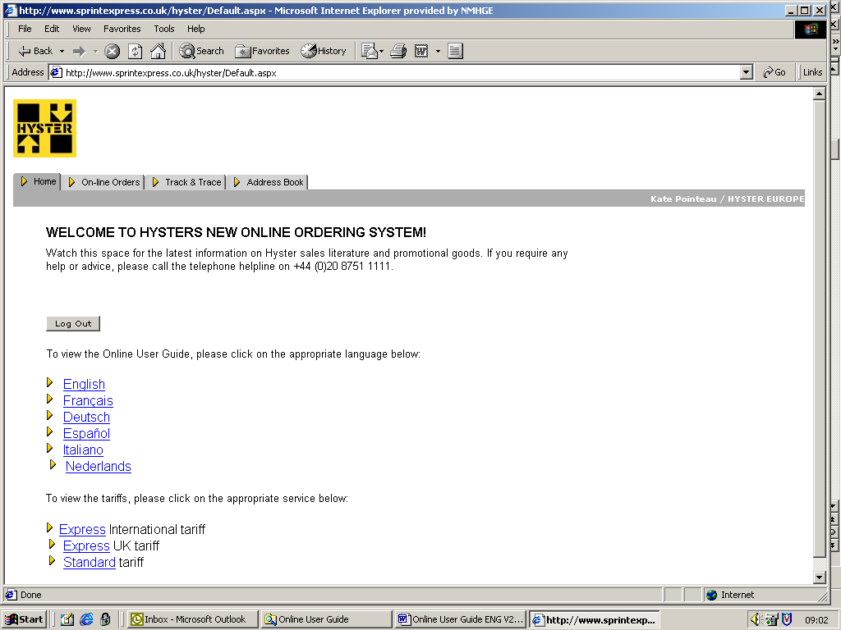

Checking and ordering stock

1. Select the ‘Online Orders’ tab at the top of the page
2. Choose from the product category options to see a list of the related product sub-categories

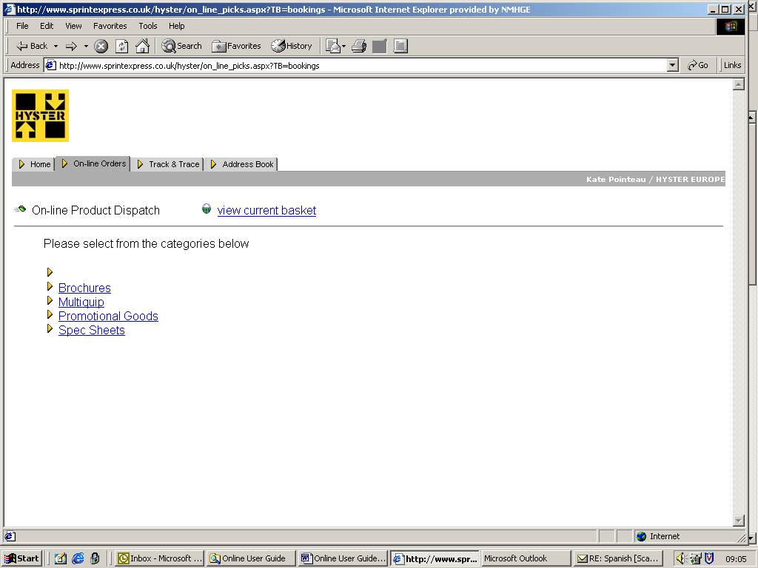

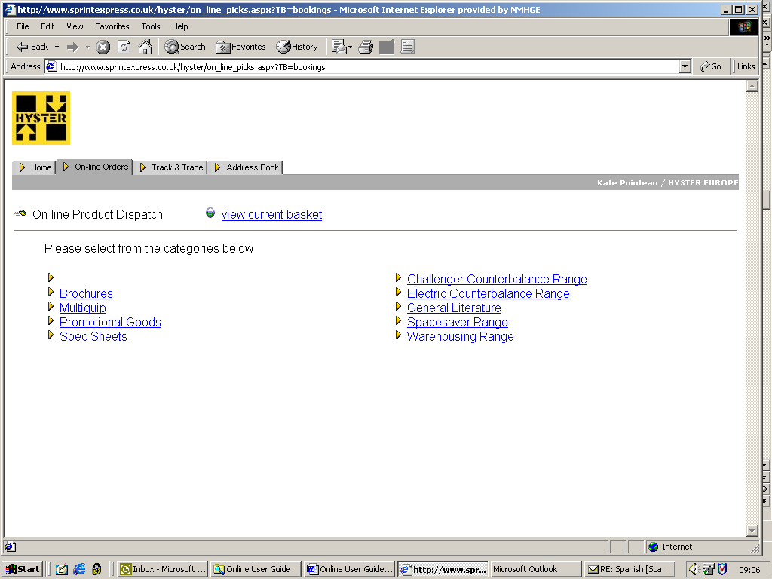

- Select from the list of product sub-category options to view all items within this search criteria. To sort these, click on the relevant blue underlined heading. To re-select a new category click on the ‘Re-select category’ link underneath the category heading

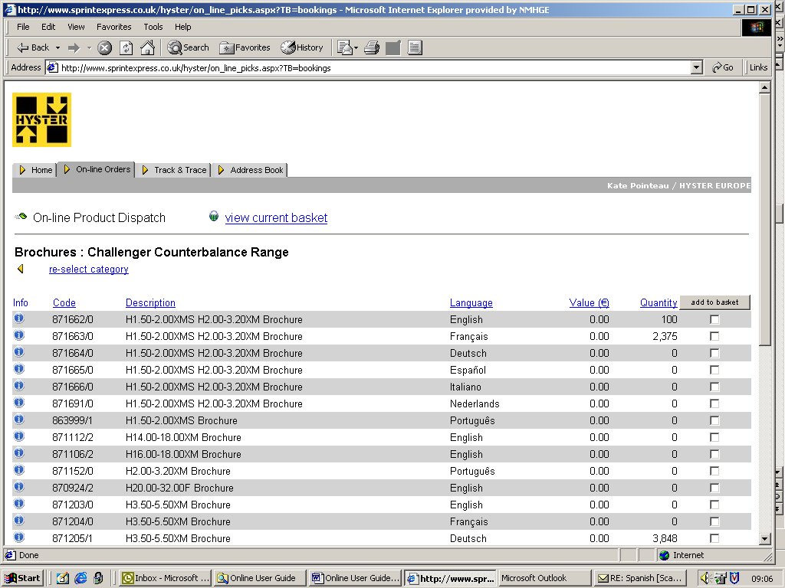

- To view further information on a specific item select the ‘i’ (information) icon to the left of each product line. To close this window click on ‘Back to product list’

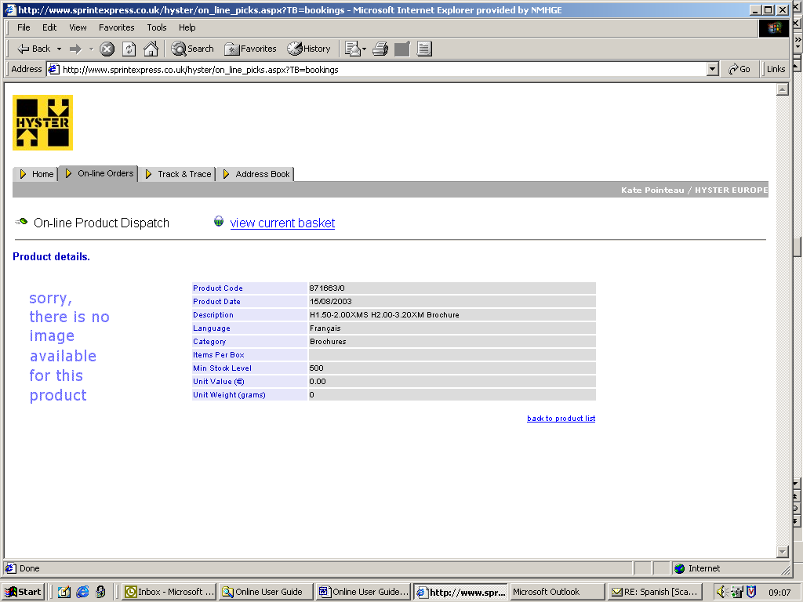

- Should you wish to make an order tick the ‘Add to basket’ box. You can select as many as you wish within a category
- Select the Quantity to pick and click on ‘Proceed to checkout’. Should you wish to add items from other categories, click 'go back to product list' where you can then click on ‘Re-select category’ and begin the above process again until you are happy that you have all the items in your shopping basket that you require. Please note if the quantity available is lower than the quantity you are wanting to order, your order will be rejected

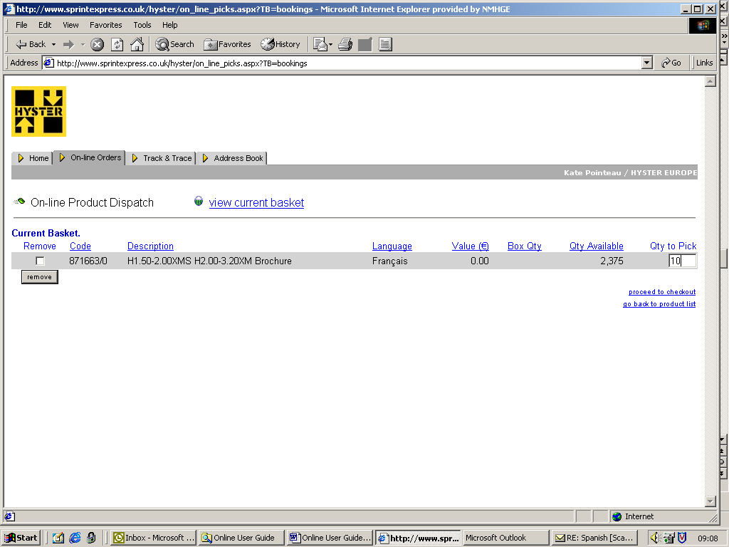

- You will then be asked to select a location for delivery. At this point you either need to select an address from the dropdown list or add a new delivery address by clicking on the ‘new address’ link. Simply edit or add your details and you will be taken through to the next screen

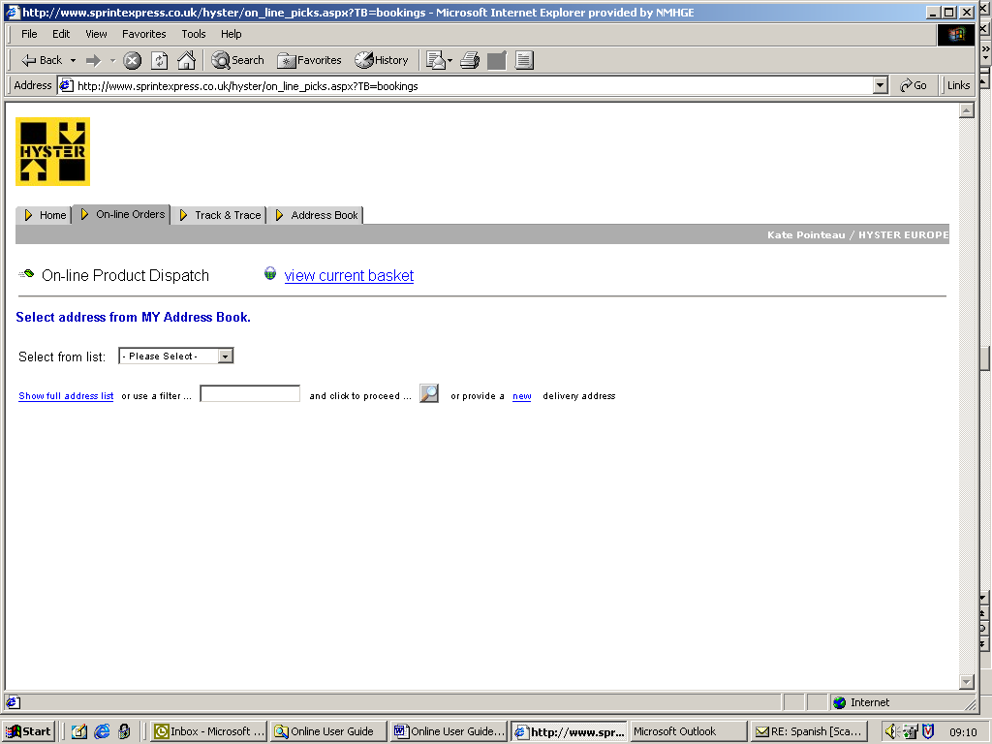

- Pick the appropriate delivery option (‘Standard’ or ‘Express’), insert any relevant text for the delivery instructions and or packaging note and press ‘Check out’

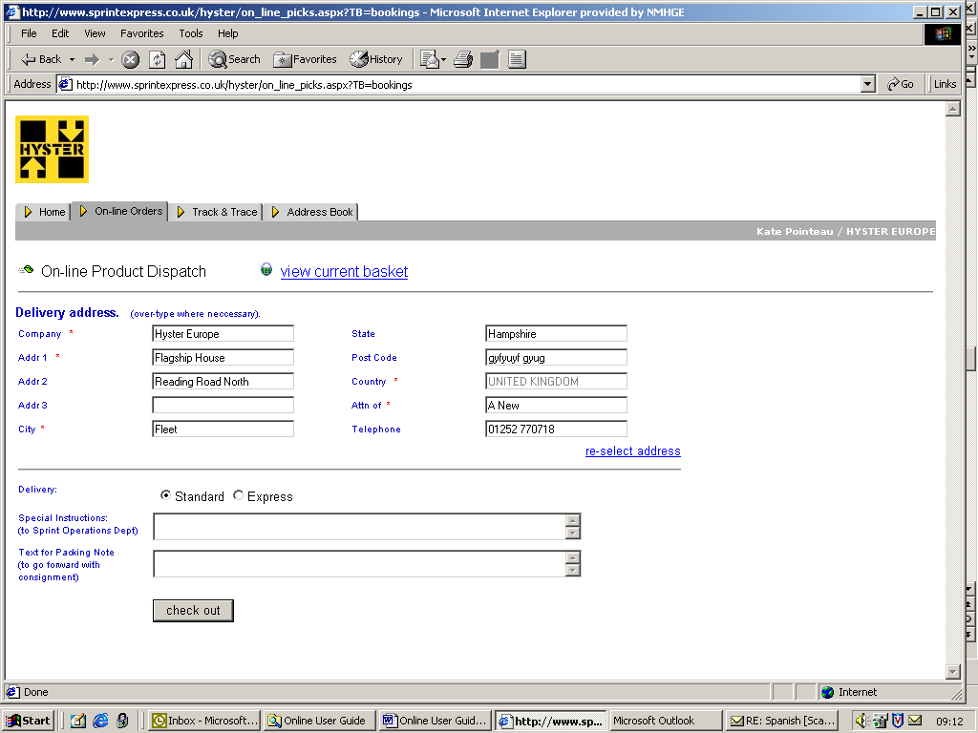

Check the booking details and confirm by clicking on ‘Submit booking’

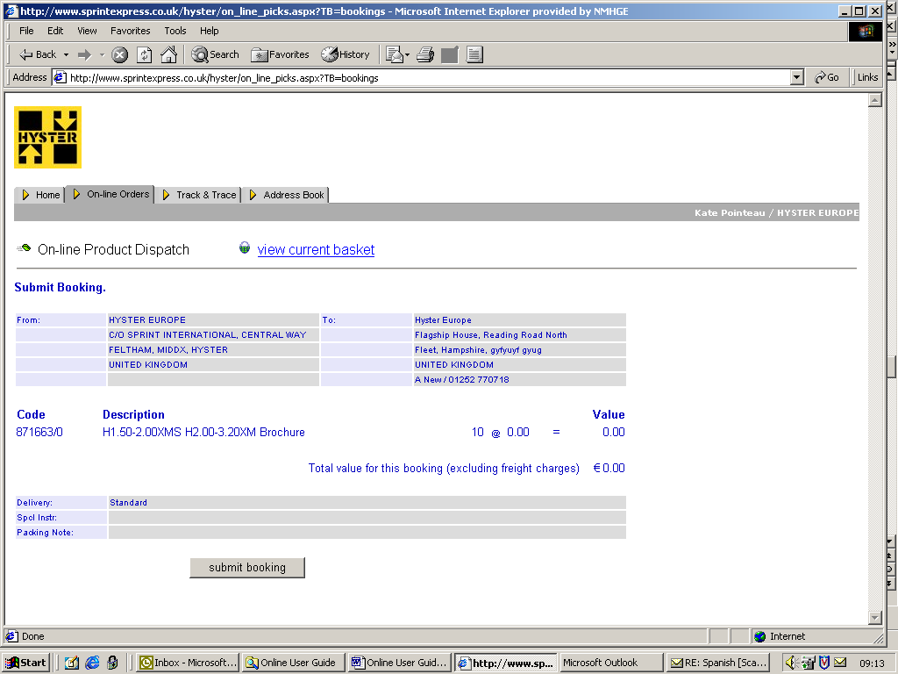

You will then see the screen below indicating that your order is being processed. Click on ‘refresh’ for an updated status

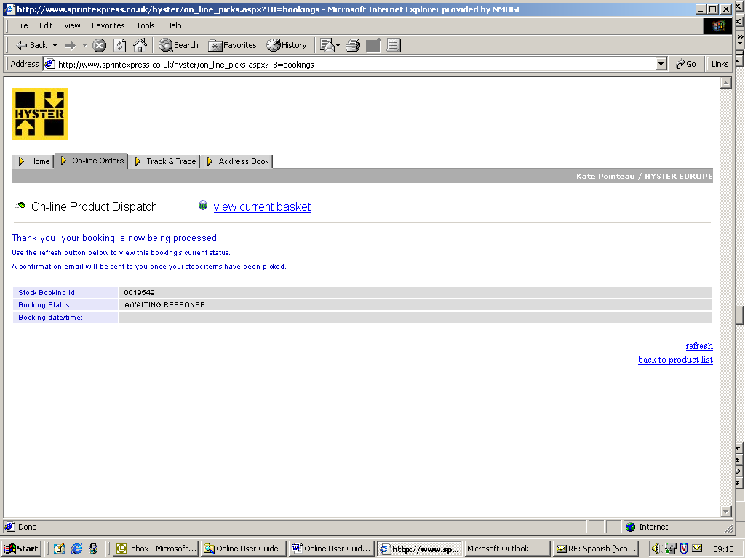

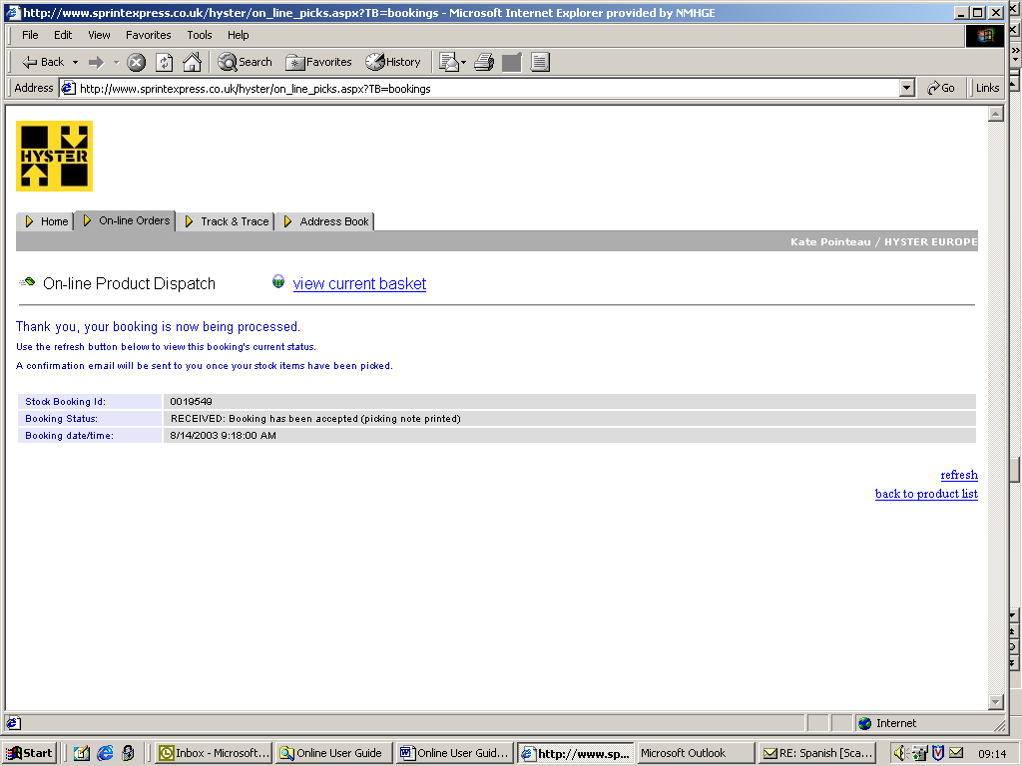

Your order has now been completed and will be despatched within the next 24 hours. You will also receive a notification of your order via email

Pricing up your order

- To get an idea of the freight costs for your order, check the freight matrices for the standard and express deliveries for different locations situated on the Home Page

Track and Trace

- Select the ‘Track & Trace’ tab at the top of the page for a list of all items ordered under this user ID. View ‘status’ for order progress

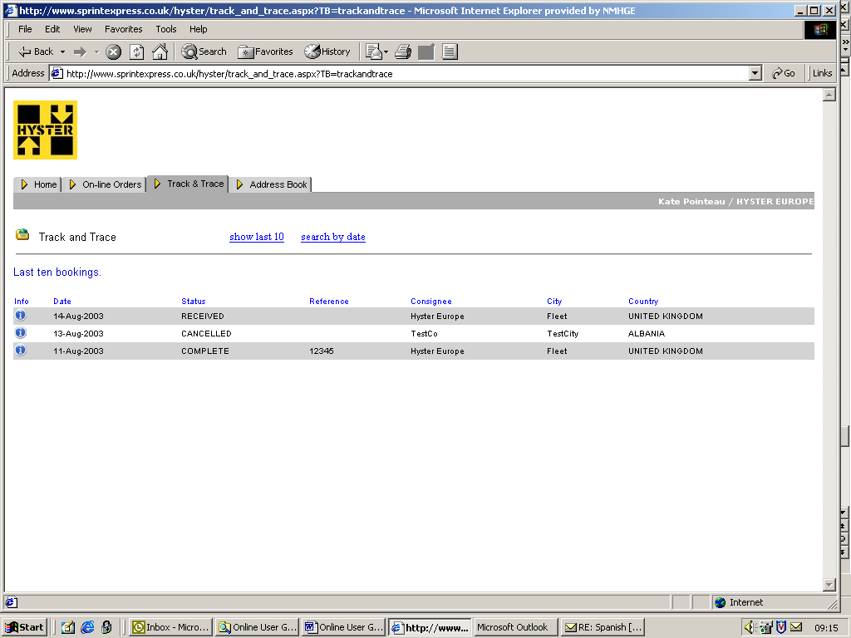

- Address Book

  - Select the ‘Address Book’ tab

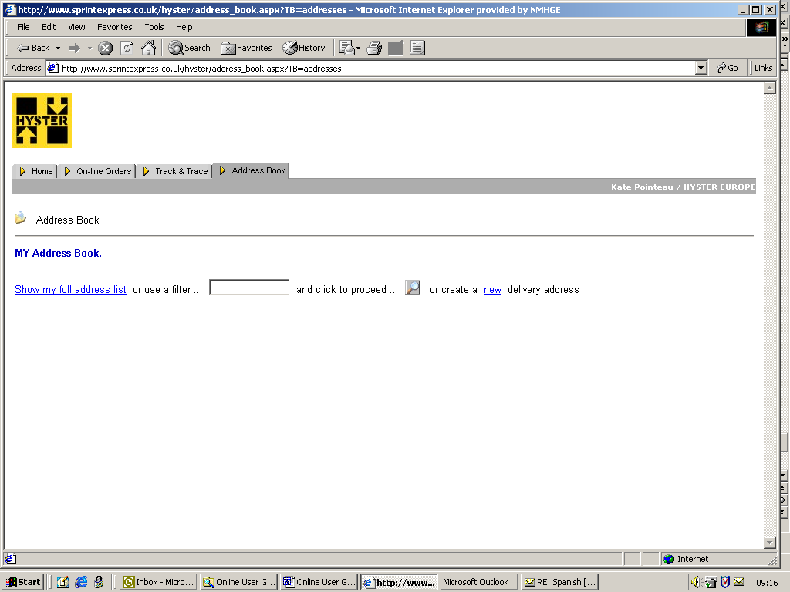

  - To create a new delivery address click on ‘new’ and fill in the details required. This will then appear as an option on the dropdown list when ordering stock. To view all addresses click on ‘Show my full address list’. To edit an existing address click on the ‘i’ icon, amend details and click on save. To remove tick the appropriate box

- Useful Information

  - If you encounter any problems with using the system or have any further enquiries regarding an order, please call the helpline on +44 (0)20 8751 1111
  - If you do not have online access, please notify Amanda New by emailing Amanda.new@nmhg.com and I will provide you with the latest order form which can be faxed to +44 (0)20 8890 9090
  - If you have any feedback please email Amanda New at Amanda.new@nmhg.com or Alison Sealy at efhsealy@nmhg.com at the Marketing Communications department in Fleet
  - Please note that the existing service through Wavelength is no longer in operation

